IHMS
Integrated Hotel Management System
Admin Department
SOFTWARE DOCUMENTATION
Prepared by: [Team member names]
Submitted to: [Instructor / Adviser]
Course and school: [Course code, school name]
19 October 2026

Overview of the Proposed Software
The development team proposed a web-based application entitled IHMS, a hotel management system whose Admin department serves as the system-control workspace. The software gives authorized administrators one place to manage employee accounts, the department directory, roles and permissions, global settings, security monitoring, notifications, and database backups. The developers would like to bring forward IHMS to reduce the time spent on account administration and to make access to hotel operations traceable and secure.
The proponents developed IHMS using PHP 8.1 or higher and a MySQL/MariaDB database, running locally on XAMPP (Apache and MySQL/MariaDB) under Windows. The software addresses the weaknesses of manual access control, such as shared passwords, unrecorded changes, and no record of who did what. Every administrative action is permission-checked on each request and written to an append-only audit log with before and after values.
The software is accessed through a web browser. Its limitations are that the Admin department does not provide a database restore button, cannot add or delete departments (the nine departments are fixed), and does not include the operational workflows of other departments such as Front Office, Finance, Housekeeping, Food and Beverage, Kitchen, Maintenance, Security, or Management. These are outside the scope of this document.
Description of the Software
IHMS Admin is a browser-based control panel for the hotel system. It lets an administrator create employee accounts with temporary passwords, assign roles made of permission codes, review sign-in attempts and active sessions, broadcast notices to staff, inspect the database structure in read-only form, and create SQL backups. The Dashboard and the Analytics page summarise the live state of the hotel - occupancy, revenue, front-office flow, departmental work queues, sign-in activity and audit activity - computed on request from the central database. The sidebar shows only the pages that the signed-in user is permitted to open, and the server checks the permission again on every API request.
The user interface follows a left sidebar for navigation (the Administration section), a top bar with a notification bell, and content pages made of searchable tables, filter bars, and modal forms. The interface is themed in dusty pink, khaki and cream, and the dashboard and the Analytics page draw inline SVG charts (line, column, donut and bar views) from figures computed live in the central database. Buttons trigger actions such as creating an account, saving a setting, approving a request, or downloading a backup.
Features of the Software
 | Features
ACCOUNT AND ACCESS | Employee accounts (create, edit, activate, deactivate, unlock, temporary password reset) | Department directory (nine fixed departments) | Roles and permissions (built-in and custom roles, permission grants per module)
 | Sign-in with forced password change on temporary passwords | Profile page with picture upload and password change
Table 1.1 Account and access features
 | Features
SECURITY AND MONITORING | Dashboard indicators with live analytics | Analytics page (occupancy, revenue, workload, access) | Audit log | Login activity | Active sessions with revoke | System errors with error ID
 | Approvals visibility | Notifications and broadcast | System settings | Central database overview (read-only) | SQL backups
Table 1.2 Security, monitoring and system features
Software Development Team Structure
[ Insert team structure chart: project manager, programmers, designer, tester, documenter with names ]
Software Development Team Figure 1.1
Software Development Tool Choice of SDLC Model
[Confirm the model your team used.] The sample template used the spiral model because it passes through every phase repeatedly with gradual improvement, and changes between phases can be made. IHMS was built in incremental releases (database migrations, API controllers, then browser pages), which fits an iterative model such as the spiral model. Replace this paragraph if your team used another model.
Software Planning
[ Insert Gantt chart ]
Gantt Chart Figure 1.2
The software development application is intended to finish within [__] weeks. In the first weeks, the team conducted planning and requirements analysis. This was followed by the logical and physical design of the database and the Admin pages, then coding of the migrations, controllers, services and pages, then testing of permissions, safeguards and error handling, and finally deployment and the submission of the final output. [Edit the weeks to match your actual schedule.]
Software Analysis
Before the developers tackled the software, they gathered and documented the requirements of the stakeholders so that misunderstandings among the team could be avoided. The analysis covered functional requirements, non-functional requirements, performance requirements, and quality requirements. A requirement specifies what the system should do and what limits it has; it does not specify how it will be programmed.
Software Specification:
IHMS runs on a web server with PHP 8.1 or higher and a MySQL or MariaDB database (InnoDB tables). Setup uses migration, seed and create-admin scripts. The first administrator account is provisioned once with database/create-admin.php, and there is no default username or password. Database changes are made only through migrations.
Hardware Specification:
The system was developed and run locally on a Windows computer using XAMPP. Users open the system through a modern web browser. [Insert the exact specifications of the development computer, such as processor, RAM and storage.] Backups are stored as SQL files in storage/private/backups, outside the public web folder, so enough storage must be available for them.
Functional Requirement No. | Functional Requirement Description
FR 1 | Sign in with username or email and password, with a forced password change for temporary passwords.
FR 2 | Create, edit, activate, deactivate and unlock employee accounts, and issue one-time temporary passwords.
FR 3 | Assign roles to employees, with checks for department-scoped roles.
FR 4 | Create, edit and delete custom roles and manage permission grants, keeping the critical administrator permissions.
FR 5 | View the fixed department directory and edit department names and descriptions.
FR 6 | View and update validated system settings (hotel display, currency, times, tax, service charge, session and lockout limits).
FR 7 | Record and display the audit log, login activity, active sessions and system errors.
FR 8 | Revoke active sessions of other users.
FR 9 | Show approval requests and allow decisions only to users holding the required permission.
FR 10 | Broadcast notifications to all active staff or one department and show read counts.
FR 11 | Show a read-only central database overview with health checks and table details.
FR 12 | Create and download SQL database backups.
Table 1.3 Functional requirements
By analyzing the gathered data, the team identified the functional requirements above. After the administrator signs in, the sidebar shows only the pages allowed by the assigned permissions. Every change is validated by the server and recorded in the audit log.
Non-Functional Requirements
Security | Passwords are stored as hashes; temporary passwords are shown once; sessions expire (default 30 minutes); accounts lock after repeated failed sign-ins (default 5 attempts, 15 minutes); permissions are checked on every request.
Availability | The system is available whenever the web server and database are running.
Reliability | Critical safeguards: at least one active System Administrator must remain; the audit trail is append-only; changes are recorded with before and after values.
Capacity | [Insert tested number of users and records.] Backup size depends on the database size.
Usability | Navigation shows only permitted pages; searchable and filterable tables; clear validation and error messages with an error ID.
Table 1.4 Non-functional requirements
Nonfunctional requirements do not change what the system does, but they affect how well it performs. They concern security, availability, reliability, capacity, and usability of the software.
Software Designing
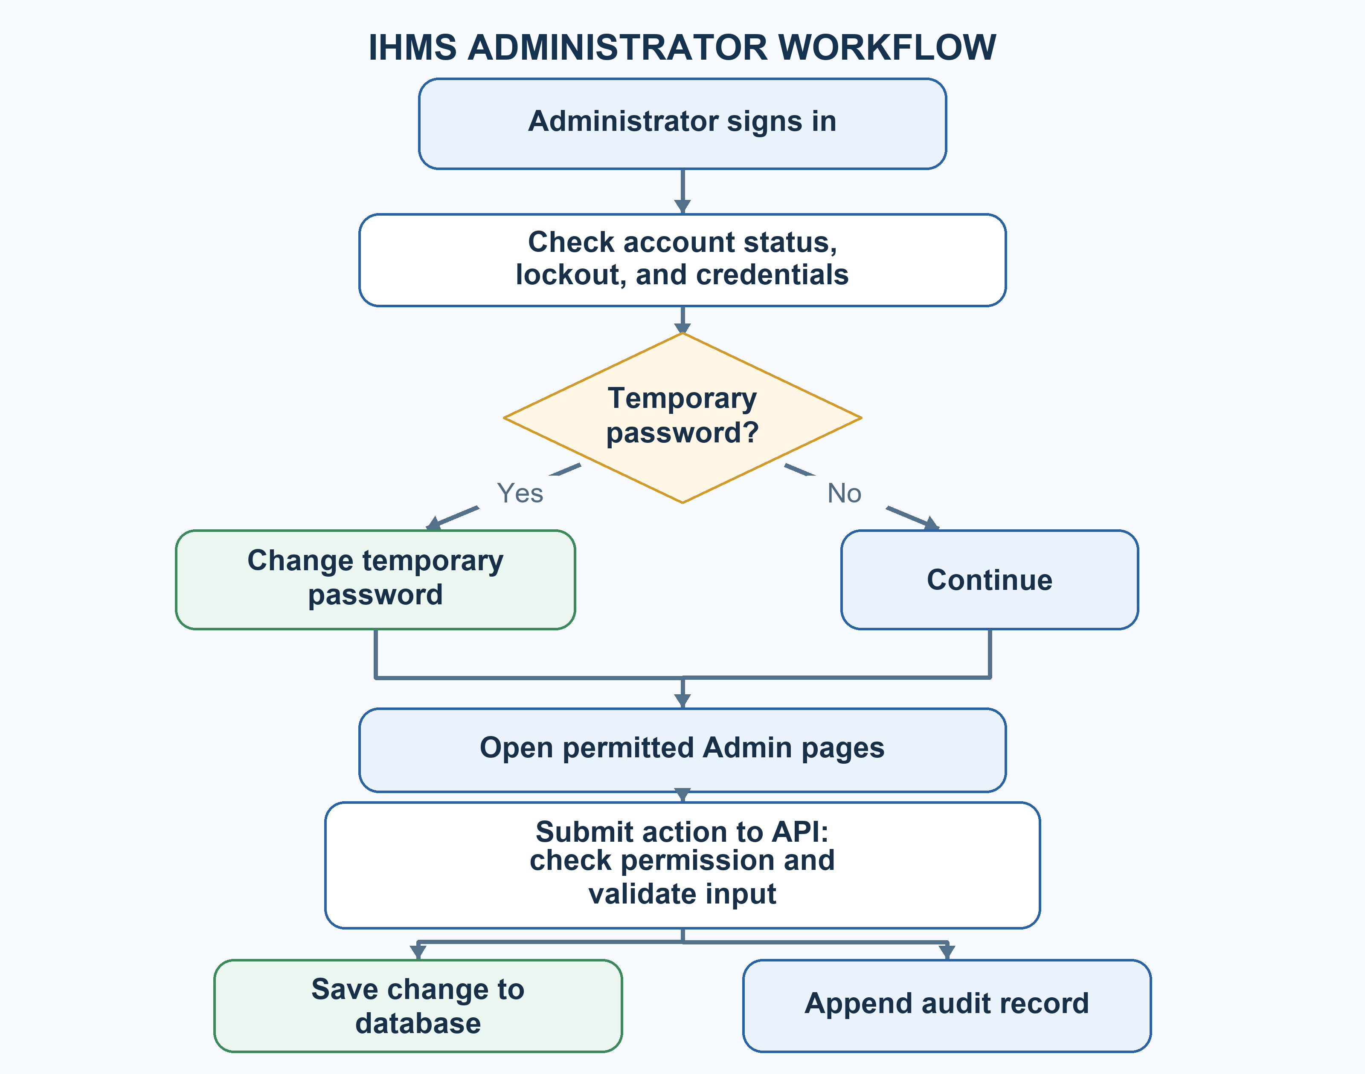
Figure 1.3 Logical diagram for IHMS Admin
Figure 1.3 shows that the administrator signs in, and the system checks the account status, lockout and permissions. If the password is temporary, the administrator must change it first. After that, the administrator may open the Admin pages shown in the sidebar. Each action goes through the API, which checks the permission, validates the input, saves to the database, and writes an audit record.
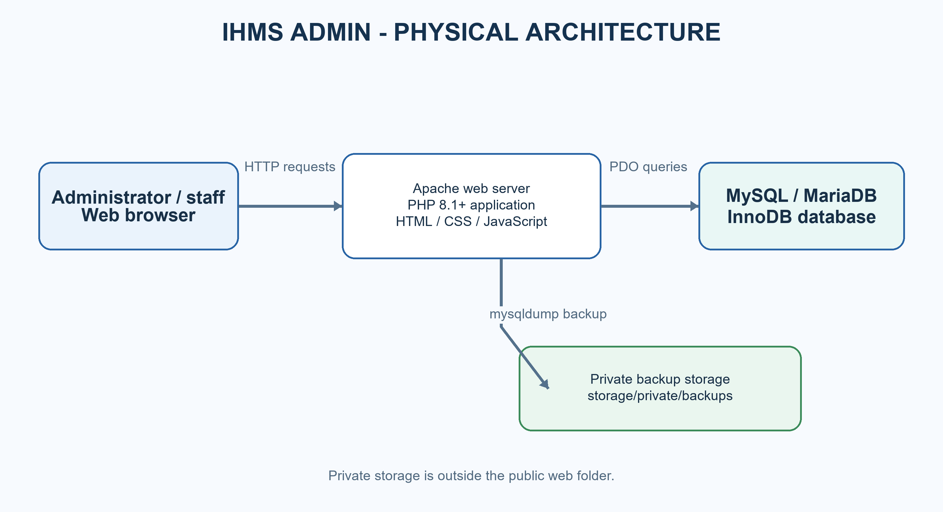
Figure 1.4 Physical diagram for IHMS Admin
In Figure 1.4, the browser sends requests to the PHP application on Apache. The application reads and writes the MySQL/MariaDB database and stores backup files in a private folder that is not reachable from the web.
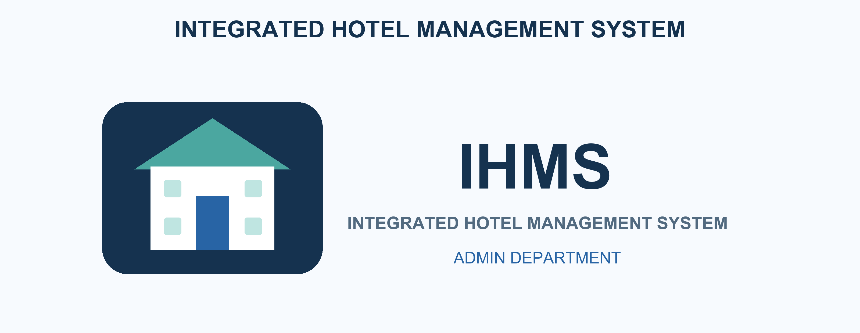
Figure 1.5 IHMS name and logo
USER INTERFACE OF THE ADMIN
SIGN IN AND PROFILE
[ Insert screenshot(s) ]
Figure 1.6 Sign-in page and Figure 1.7 Forced password change
The administrator opens the IHMS link and signs in with the username or email and the password created for the account. If the password is temporary, the system only allows account and password operations until it is changed. The My profile page shows the account details, allows uploading a profile picture, changing the password, and signing out.
DASHBOARD
[ Insert screenshot(s) ]
Figure 1.8 Admin dashboard
The dashboard shows active and total employees, locked accounts, signed-in sessions (30-minute window), failed and successful sign-ins in the last 24 hours, system errors in the last 24 hours, pending approvals, and the administrator's unread notifications. It also shows employees by department as a proportional bar and the most recent audit events. The dashboard does not change any record.
EMPLOYEES
[ Insert screenshot(s) ]
Figure 1.9 Employee list and Figure 2.0 New employee form
The Employees page lists name, employee number, username, department, roles, status or lock state, and last sign-in. It can be searched by name, username, email or employee number and filtered by department and status. New employee asks for username (3 to 60 characters), first and last name, email, optional phone, primary department, and initial roles. The system assigns an employee number and generates a temporary password that is shown once. Edit changes name, email, phone and department, while Roles changes role assignments. Activate, Deactivate, Unlock and Reset password are available as actions. Deactivating or resetting a password signs the user out, and the last active System Administrator cannot be removed.
DEPARTMENTS
[ Insert screenshot(s) ]
Figure 2.1 Department directory
The department page shows the nine fixed departments with code, name, description, total and active employees, and status. Names and descriptions can be edited. A department with active employees cannot be deactivated, and the Admin department cannot be deactivated. Departments cannot be added or deleted.
ROLES AND PERMISSIONS
[ Insert screenshot(s) ]
Figure 2.2 Roles list and Figure 2.3 Permission grants
The roles page lists each role with its scope, number of employees, number of permissions, and whether it is built-in or custom. Custom roles can be created with a unique lowercase code. Permission grants are selected by module. Built-in roles cannot be deleted, a custom role can only be deleted when no employee has it, and the System Administrator role must keep user.manage, role.manage and settings.manage. Every permission change is audited.
SYSTEM SETTINGS
[ Insert screenshot(s) ]
Figure 2.4 System settings
The settings page shows hotel name, currency (three-letter code), check-in and check-out times, VAT rate, service charge, session minutes, maximum login attempts, and lockout minutes. Each value is validated and unknown settings are rejected. Changes are audited.
AUDIT LOG, LOGIN ACTIVITY, SESSIONS AND ERRORS
[ Insert screenshot(s) ]
Figure 2.5 Audit log, Figure 2.6 Login activity, Figure 2.7 Active sessions and Figure 2.8 System errors
The audit log records the actor, action, entity, time, IP address and before and after values, and can be filtered by actor and date. Login activity lists attempts with username, IP, result, reason and device. Active sessions list the user, IP, device and last activity, and the administrator can revoke the session of another user. System errors can be searched by error ID, message or path and show the recorded context.
APPROVALS AND NOTIFICATIONS
[ Insert screenshot(s) ]
Figure 2.9 Approvals and Figure 3.0 Broadcast message
The approvals page lists requests and can be filtered by pending, approved or rejected. Only a user with the permission required by a request can decide it, and nobody can decide their own request. The notifications page lists sent notices with severity, recipient count and read count. A broadcast needs a title (up to 150 characters), a message (up to 500 characters) and a severity, and can go to all active staff or one department.
CENTRAL DATABASE AND BACKUPS
[ Insert screenshot(s) ]
Figure 3.1 Central database overview and Figure 3.2 Backups
The central database page is read-only. It shows the number of tables, database size, foreign keys, protection triggers, migration status, health checks, and table details such as columns, keys and relationships. The backups page lists SQL dumps and allows creating and downloading them. Backups are stored outside the public web folder. The system has no restore button; restoring is done by an authorized operator using the MySQL client.
ROLE ACTIVITY DIAGRAM
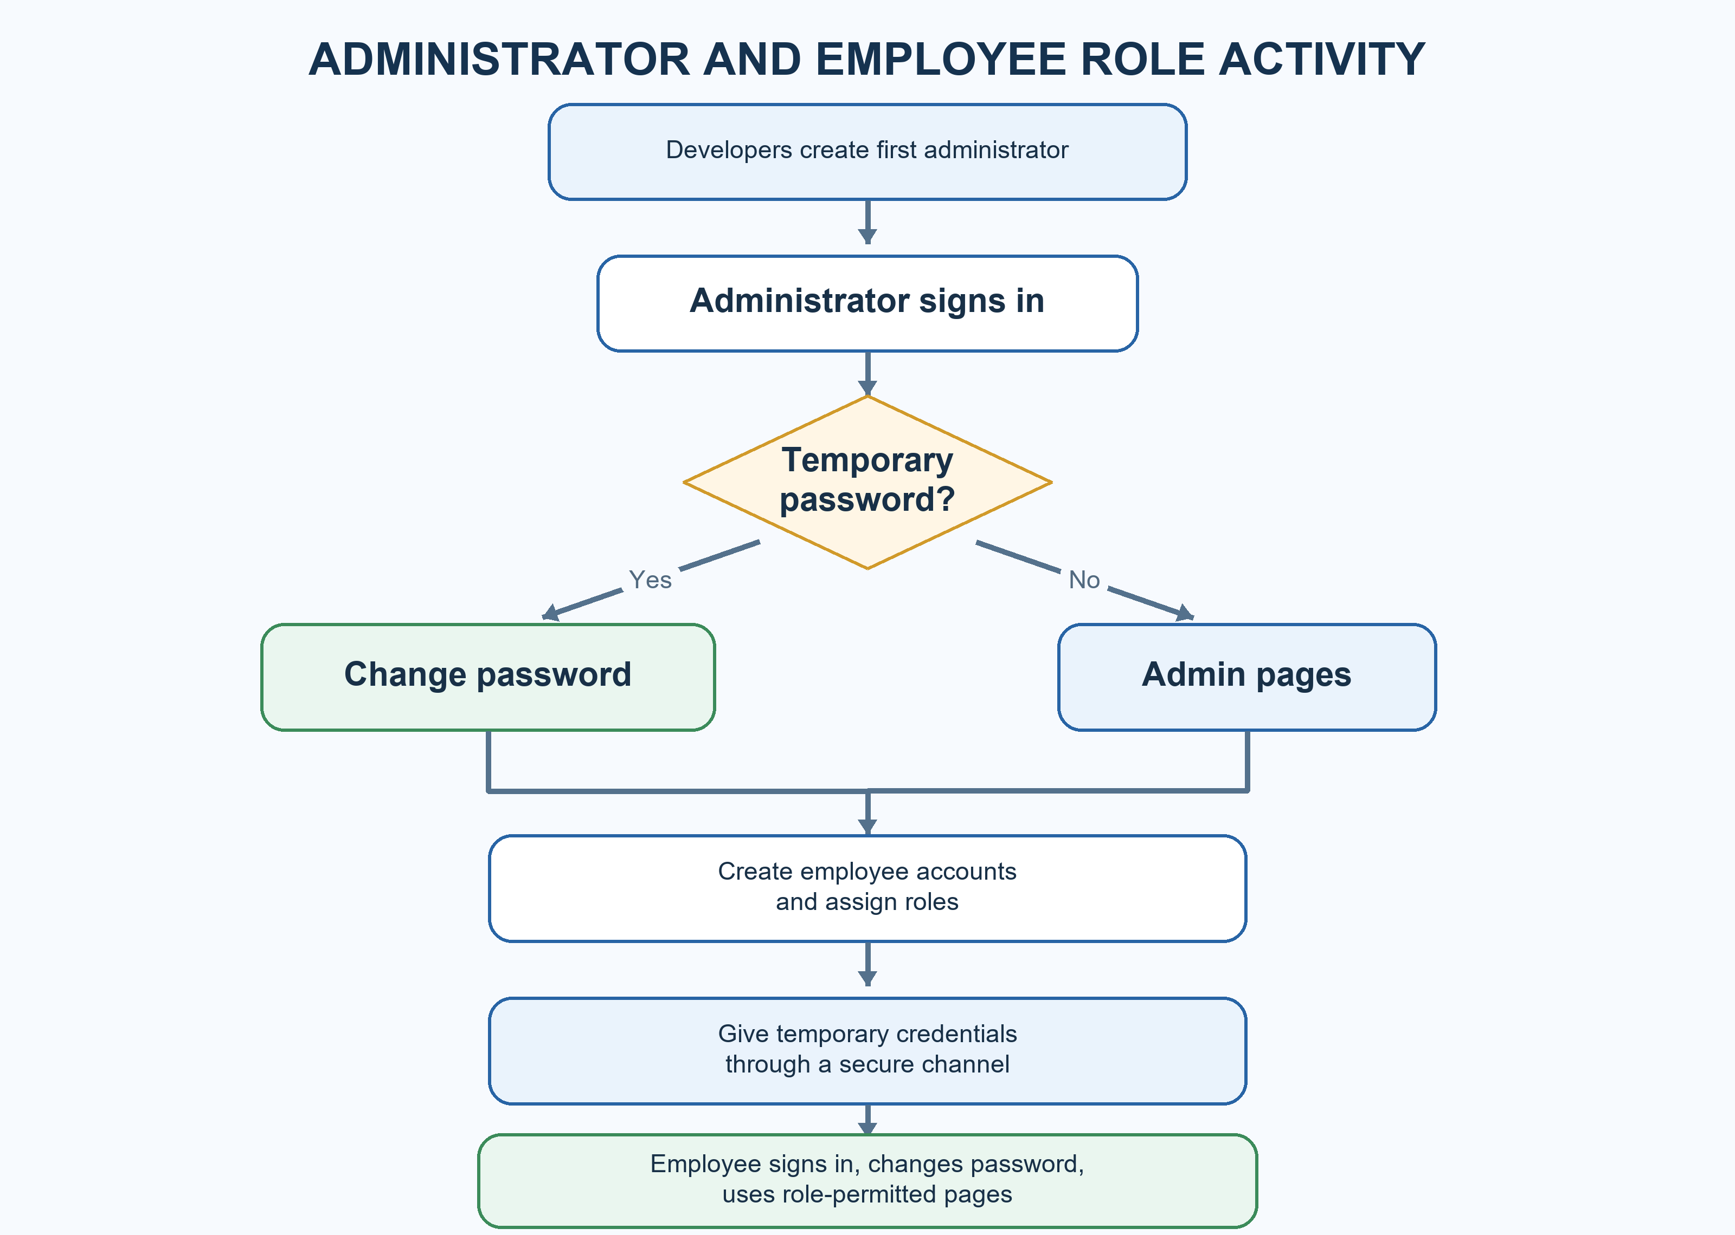
Figure 3.3 Role activity diagram
In Figure 3.3, the first administrator account is created once by the developers using the create-admin script. The administrator signs in, changes a temporary password if required, and opens the Administration pages. The administrator creates employee accounts and gives temporary passwords to staff by a secure channel. Employees sign in, change the temporary password, and use only the pages allowed by their roles. The administrator monitors the dashboard, audit log, login activity and errors, and creates database backups regularly.
SOFTWARE REQUIREMENTS
Frontend: HTML, CSS and JavaScript pages served by the application. The pages call the API and display only the menu items allowed for the signed-in user. [Add the framework or libraries if any.]
Backend and Database: PHP 8.1 or higher handles the API routes, controllers and services. MySQL or MariaDB with InnoDB tables stores the data. Changes to the database structure are made through migrations, and mysqldump is used to create backups (the DB_DUMP_BIN setting is used when mysqldump is not on the PATH).
HARDWARE REQUIREMENTS
Windows computer or server | XAMPP (Apache and MySQL/MariaDB) | [Insert minimum RAM and storage]
Modern web browser | Network access to the server | Enough storage for backups

Software Implementation
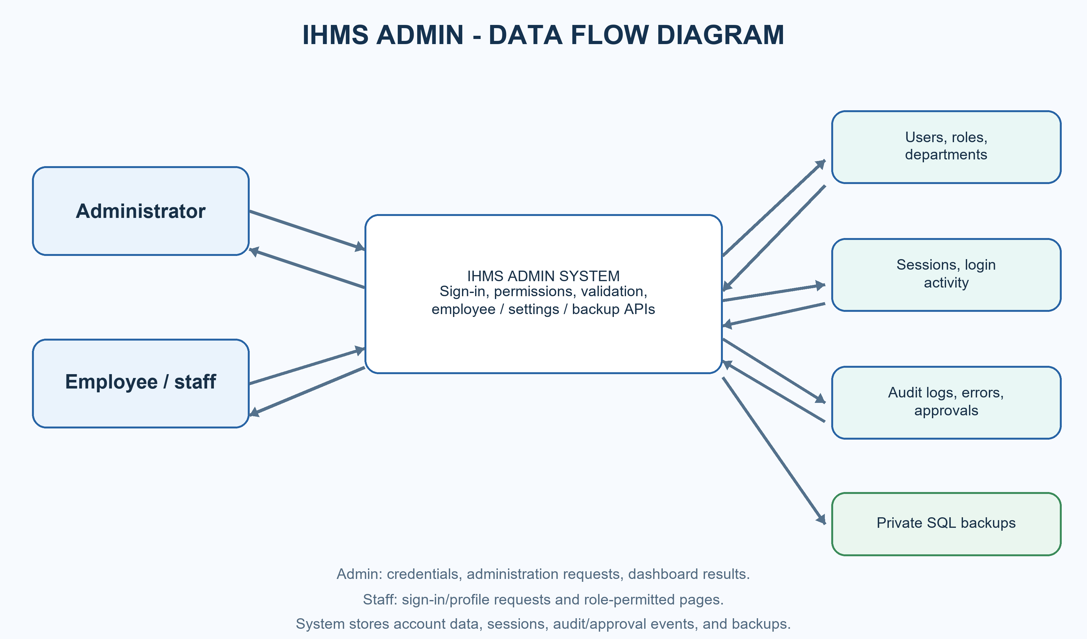
Figure 3.4 Administrator DFD
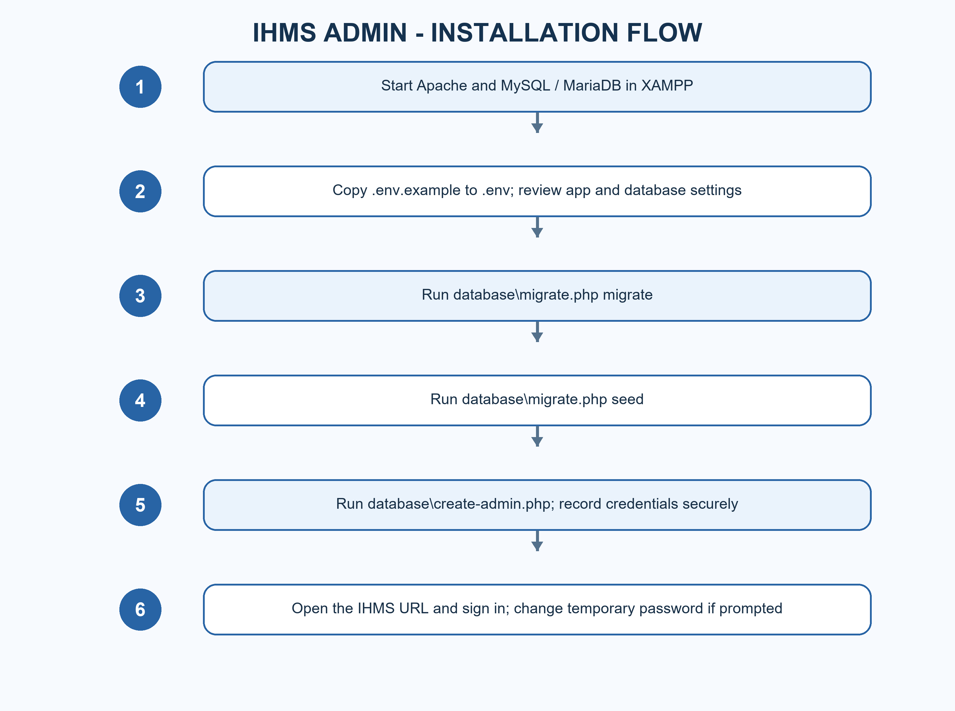
Figure 3.5 Installation DFD
INSTALLATION FLOW PROCEDURE FOR THE ADMIN
- Start Apache and MySQL/MariaDB in XAMPP.
- Copy .env.example to .env and check APP_URL, DB_HOST, DB_PORT, DB_NAME, DB_USER and DB_PASS.
- Run C:\xampp\php\php.exe database\migrate.php migrate.
- Run C:\xampp\php\php.exe database\migrate.php seed.
- Run C:\xampp\php\php.exe database\create-admin.php and securely record the one-time credentials.
- Open http://localhost/hotel-management-system/ and sign in.
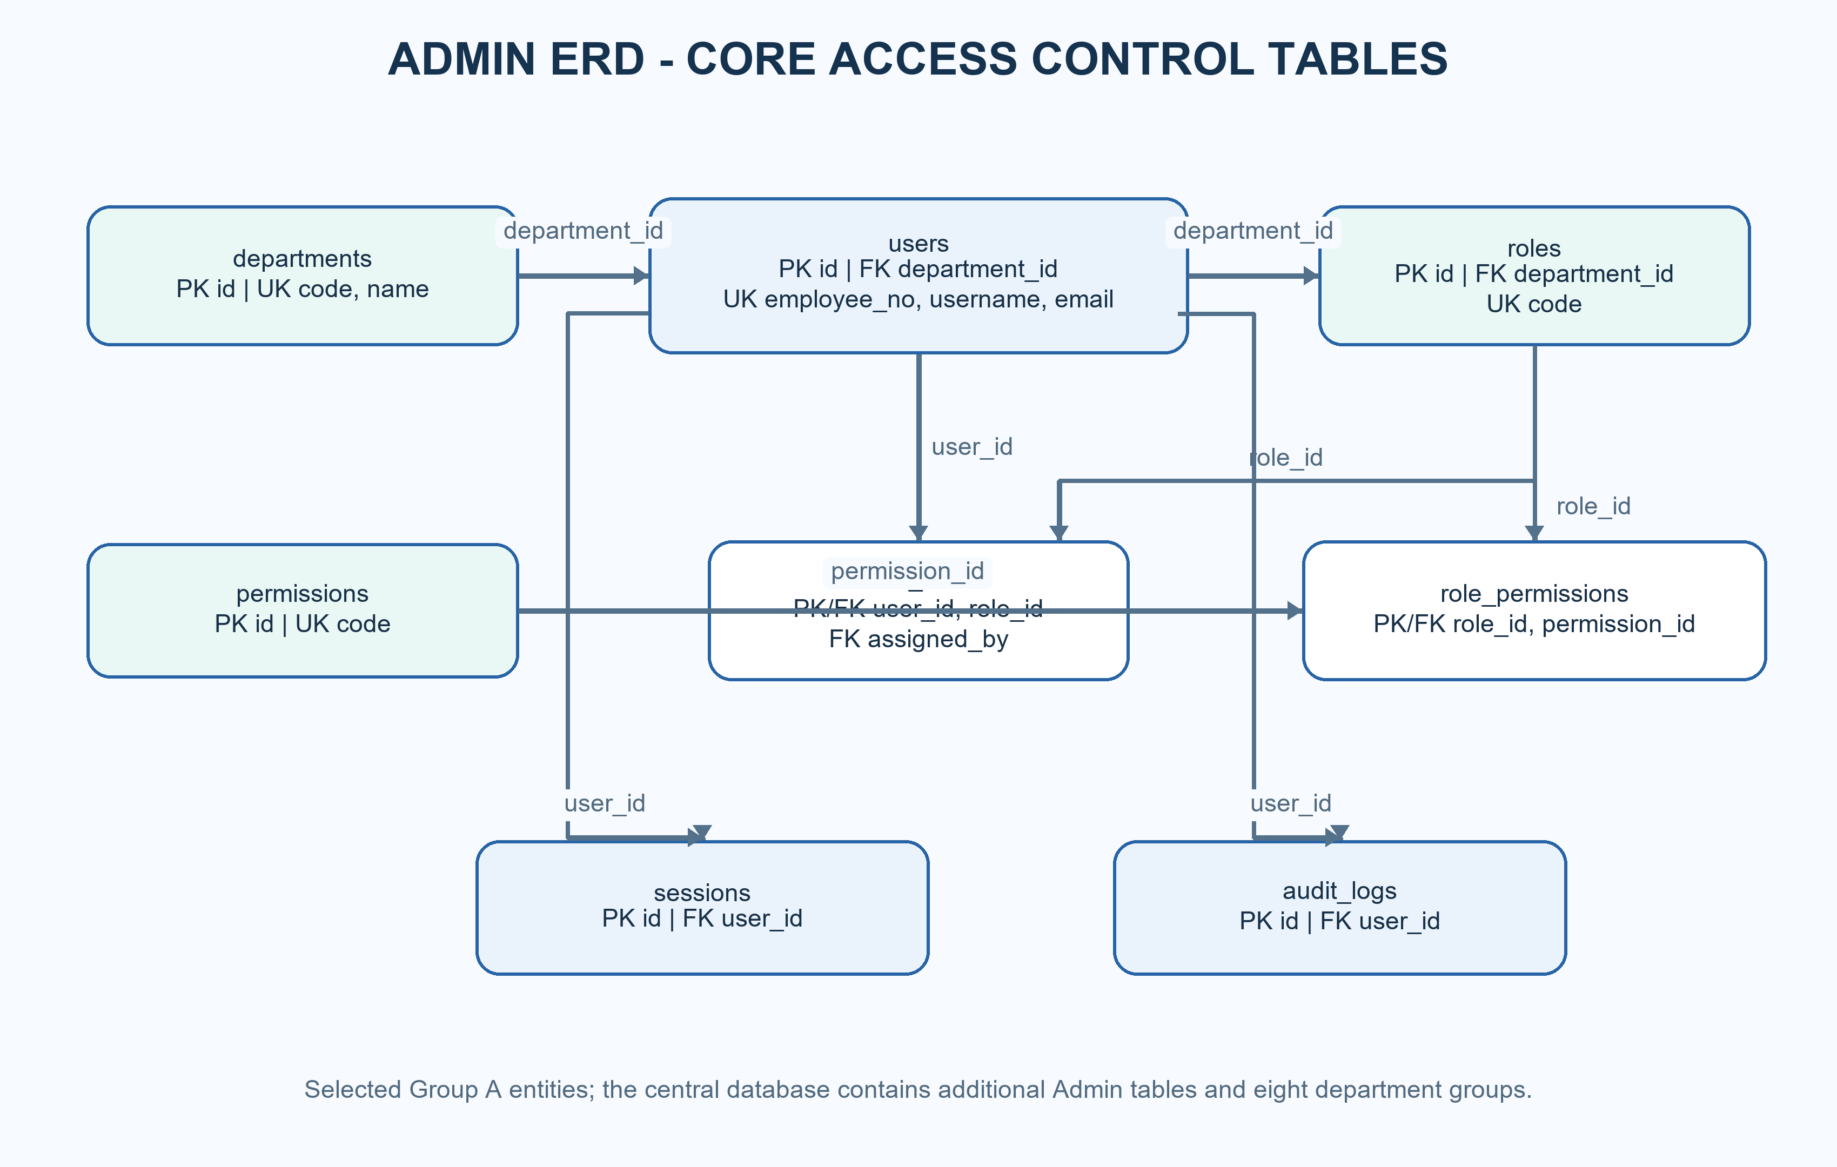
Figure 3.6 Admin ERD

"SURVEY QUESTIONNAIRE"
"IHMS ADMIN DEPARTMENT"
[Team member names]
DIRECTION: Answer the following question(s) accordingly. Put a check (/) mark on the desired answer.
No. | QUESTIONS | 5  Strongly Agree | 4  Agree | 3  Neutral | 2  Disagree | 1  Strongly Disagree
1 | The application is conveniently accessible through the website.
2 | The navigation menu is easy to understand.
3 | Creating and managing employee accounts is easy.
4 | Roles and permissions are clear and easy to manage.
5 | The dashboard gives useful information.
6 | The audit log and login activity help in monitoring the system.
7 | Error messages are clear and helpful.
8 | Creating and downloading backups is easy.
9 | The system keeps information secure.
10 | Overall, I am satisfied with the system.
Table 1.5 Usability and accessibility survey

